We are looking at the problem of missing students. A digital solution we can make is a student tracker and automatic roll marker
Requirement table
Requirement ID | Requirement | Functional or non-functional | Evidence source | Total
R1 | Must be cross compatible | Non-functional | Microsoft Form, Teacher answer using phone. | 3
R2 | Must be able to locate students | Functional | Microsoft form | 7
R3 | Must be able to update in roll | Functional | Microsoft form | 9
R4 | Must be able to run on school computer technology | Non-functional | Microsoft Form | 3

Constraint type | Constraint | Impact
Economic | Time, and no money | Must
Technology | We only have school computers and phone and are not experienced | Forced to build the software for these devices and possibly teach others.
Social | Small team of students developing it, teachers may not know how to use | Slow development and slow upkeep if any at all
Legal | Must be careful of copy right | We might not be able to use some assets
Usability | Must be able to be used by teachers | We must remove any jargon and make UI pretty

In scope | Out of scope
Auto mark roll | Cameras tracking students around school
Mark down location of students | Drone cameras
NFC readers | Auto alert of location

Brainstorm:

Student RECORD
BEGIN
RECORD Student
Name ß ()
isInClass ß false
timetable ß ()
cuLocation ß()
email ß ()
CuClass ß()

FUNCTION Student
name ß INPUT
isInClass ß INPUT
timetable ßINPUT
cuLocation ßINPUT
email ß INPUT
CuClass ß timetable[period]
END FUNTION
FUNCTION onMarkButtonPress
IF isInClass == false THEN
isInClass ß true
ELSE
isInClass ß false
END IF
END FUNCTION
END RECORD
END

Internal system auto roll marker
BEGIN:
periodRunning == true
ClassRoll ß new List<Student>
WHILE periodRunning == true
CuStudent ß INPUT
IF CuStudent.isInClass != true THEN
ClassRoll.Add(CuStudent)
CuStudent.isInClass ß true
PRINT “Welcome” + CuStudent.name
ELSE IF CuStudent == true THEN
ClassRoll.Remove(CuStudent)
CuStudent.isInClass
PRINT “Goodbye” + CuStudent.name
END IF
END WHILE
END



Teacher viewing screen
cv\\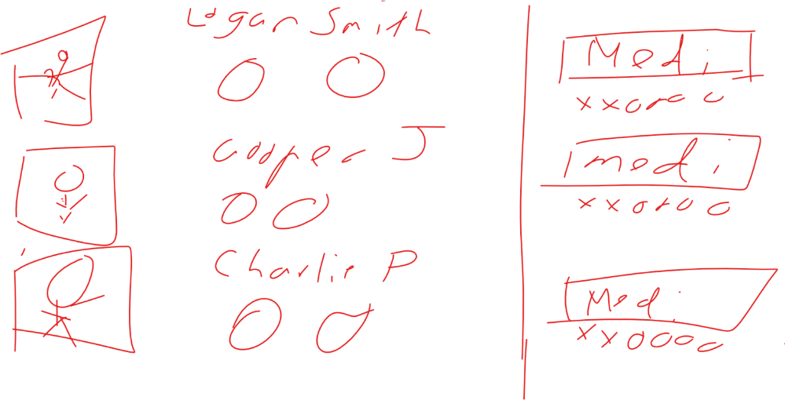

LOGIN SCREEN





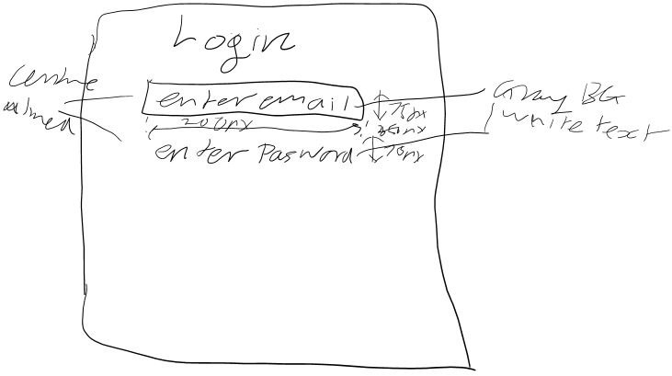



Possible Prototype visualisation


LOGIN pseudocode
BEGIN
isRunning ßtrue
WHILE isRunning
inputEmail ß INPUT
inputPasswordßINPUT
//teacher list is a list of teacher class with email, password, and other //information
FOREACH item in teacherList
IF inputEmail == teacherList.email THEN
IF inputPassword == teacherList.password THEN
isRunning ß False
END IF
END IF
END FOREACH
END WHILE
Login ß true
END

STUDENT SEARCH FUNCTION
BEGIN
isRunning ß true
WHILE isRunning
CuStudent ß INPUT
FOREACH item in studentList
If item == CuStudent.name THEN
PRINT CuStudent.cuLocation
ELSE
PRINT “Student not found”
END IF
END FOR
END WHILE
END

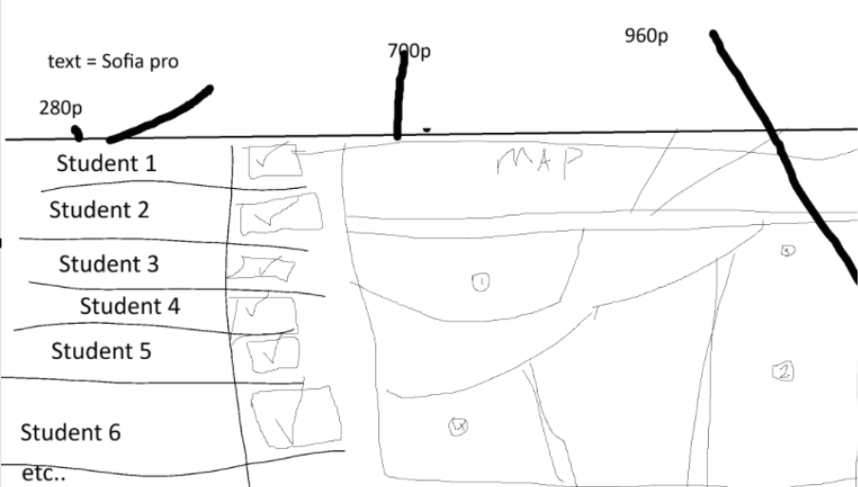z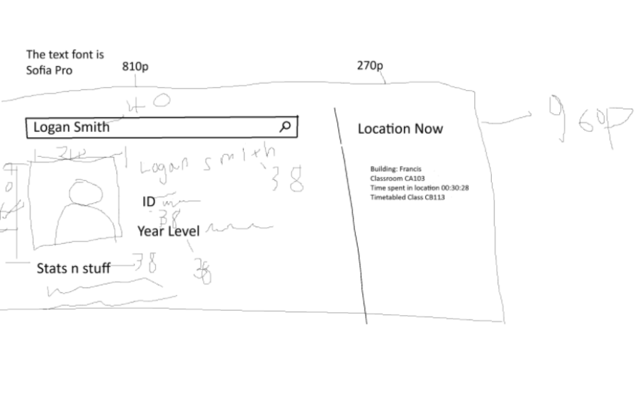
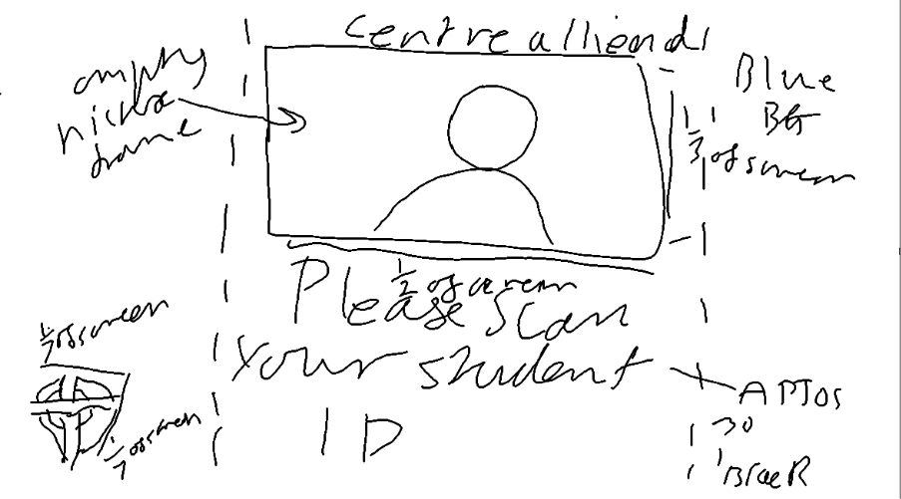
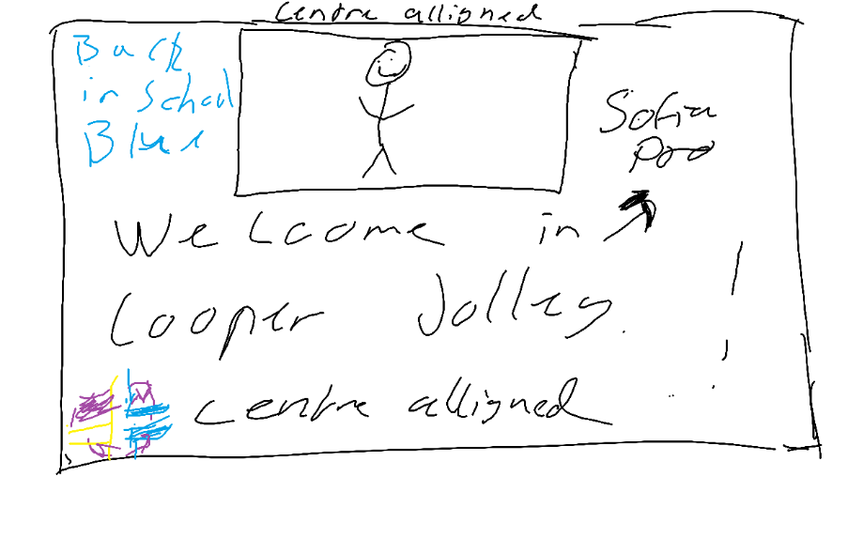
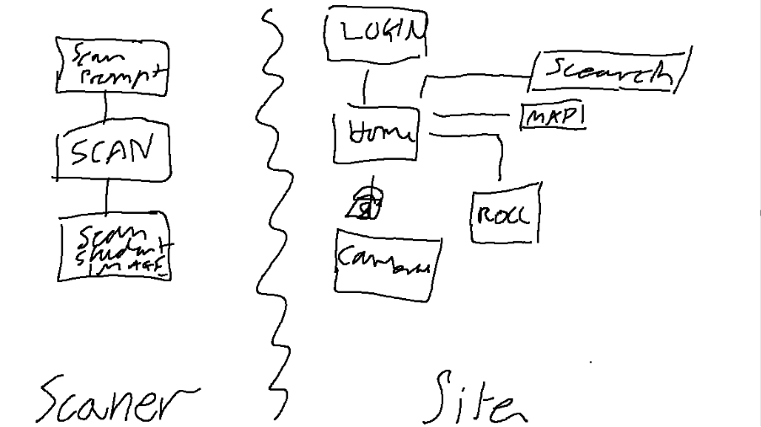

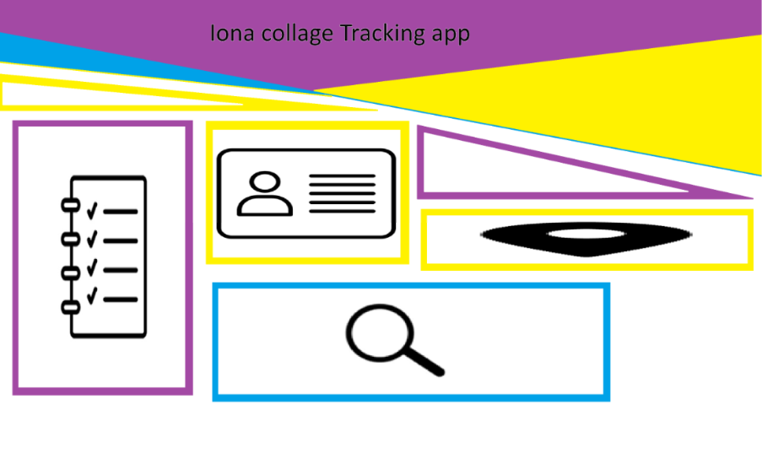
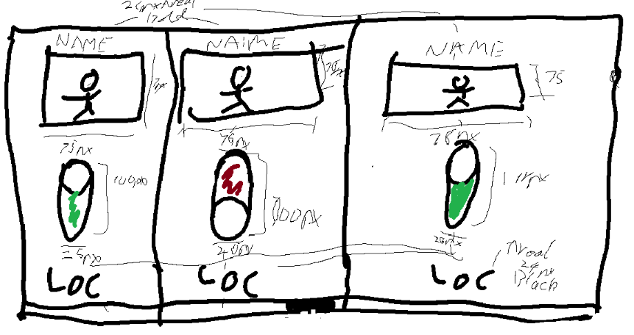
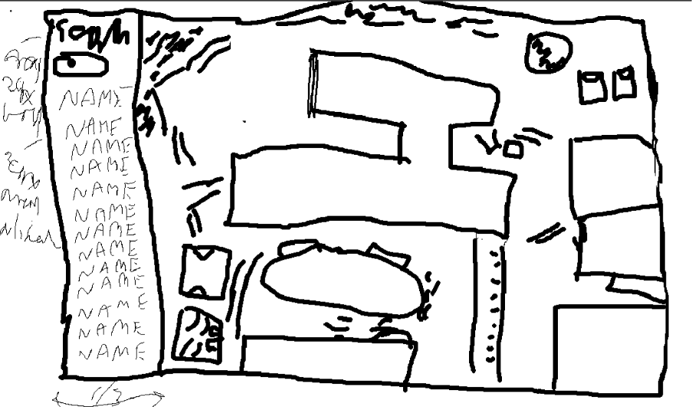

Judgement Criteria
 | Ease of use | Accessibility | Training required | Compatibility | Implement time | Ability to cope with constraints
NFC | 8/10 | I really | 5/10 | 8/10 | 9/10 | 8/10
Camera | 5/10 | Really I | 3/10 | 10/8 | 3/10 | 4/10

